FanBot Technical Design

Peter Brier (peter@kekketek.nl)
Marieke Peelen (mpeelen@kekketek.nl)
KekkeTek.nl
2013 – CC-BY-SA-NC-3.0

Revision history
Revision | Date | Author | Notes
0.1 | 3-2013 | M. Peelen | Initial version, info copied from various documents
0.4 | 4-2013 | P. Brier | Added protocol information
0.6 | 4-2013 | M. Peelen | Added use cases
0.7 | 19-04-2013 | P. Brier | Included rev 0.3 fanbot brain schematics and added layout considerations
0.8 | 21-04-2013 | P. Brier | Updated to rev 0.4 fanbot schematics
0.9 | 30-4-2013 | M.Peelen | HUB picture updated, software additions
1.0 | 30-4-2013 | P. Brier | Added info on USB communication
1.1 | 20-5-2013 | P. Brier | Added more info on HUB protocol
1.2 | 10-6-2013 | P. Bruer | Added VID / PID

TODO:
- VID/PID aanvragen voor fanbot & hub
VID: 0x1FC9 (NXP) , PID: 0x8066 (Fanbot) PID: 0x8067 (Hub)

- workshop server/client software beschrijven
- Software updater functie beschrijven

Contents
1 Introduction 3
2 Fanbot 3
2.1 Actuator 4
2.2 Light 4
2.3 Communication 4
2.4 Power supply 4
2.5 Connectors 5
2.6 Microcontroller 5
2.7 Fanbot “Brain” PCB 5
2.8 Fanbot HUB PCB 6
2.9 Power supply 6
3 Communication 7
3.1 HUB Communication 7
3.2 PC to HUB Communication protocol 8
3.3 Fanbot positions and addressing 9
3.4 Communication between HUB and robot 10
3.5 Communication Protocol between HUB and robot 10
3.6 Communication between PC and Fanbot 11
3.6.1 MSD mode 11
3.7 HID mode communication 12
3.8 Communication between Control application and proxy 13
4 Software 14
4.1 Control application 14
4.2 Control application use case 14
4.3 Fanbot program 15
4.4 Workshop programming tool 16
4.4.1 Fanbot HID interface program 17
5 Stand 19
6 Schematics & Bills of materials 20
6.1 Fanbot Electrical schematics (obsolete by last production designs) 20
6.2 Fanbot Bill of materials (obsolete by last production designs) 21
6.3 Fanbot PCB layout 22
6.3.1 Mechanical and layout considerations 22
6.3.2 Silkscreen Front 22
6.3.3 Silkscreen Back 23
6.4 Fanbot HUB Electrical schematics 24
6.5 Fanbot HUB Bill of materials 24
6.6 Tinkering materials 25

Introduction
For WK Robocup 2013 in Eindhoven a workshop is developed for the young visitors (age ±8 - 15 years). Main purpose is to involve youngsters in the event and robotics technology. The goal is build a stand with robots cheering on the soccer robots. Approx 1300 robots are expected to be build, the stand will be able to accommodate at least 1000 robots. 1500 robots kits are manufactured to allow 200 kits to be used in pilot workshops.

For this event following will be developed and realized:
- Fanbot (cheering robot) kit.
- Tribune with power and control.
- Workshop Fanbot building

Fanbot
The Fanbot is a small cardboard robot that can wave (using a small RC servo) and light up (using 5 to7 LEDs in its face).
It is controlled by a microcontroller. The microcontroller can be programmed via USB (during the workshop). The robot is able to work autonomously once programmed (power applied via USB bus). A PCB has to be designed to be used in this robot. The PCB can also serve as a generic controller for educational (robotics) projects

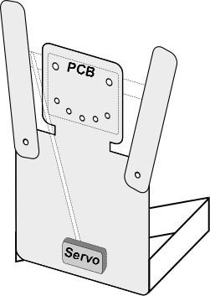  Fanbot | 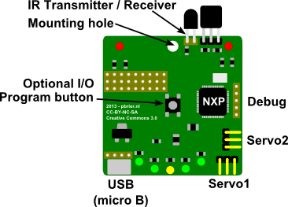  Concept of the controller PCB  (IR receiver & transmitter are optional)

Actuator
To actuate the robotic limbs, a hobby RC servo is used. The servos assume a rotor position that corresponds to the received PWM input signal. The power supply requirements are typically 3..6VDC @ 0.1 to 1A (peak). The connector is usually a 3 pin female header (2.54mm pitch) with 1=GND, 2=V+, 3=Signal. The input impedance of the signal line is typically 1 to 10kOhm.

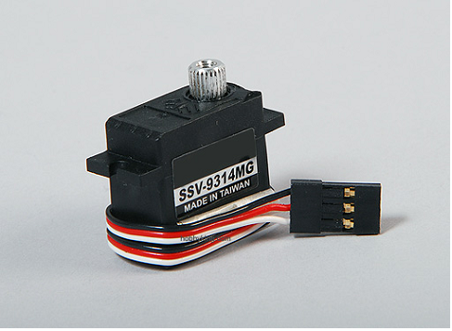
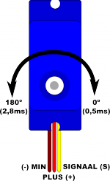
RC servo

Light
A number of LEDs are placed on the PCB, in the shape of a smiley face, to be able to make visual patterns (see PCB design). Different color LEDs can be used (e.g red, green, yellow), 5 to 7 LEDs make up the face. The LEDs are individually programmable with the micro-controller.

Communication
During the event the robot can communicate via USB (to be programmed from a PC)
In addition to the standard USB communication via the USB connector, it should be possible to signal at low speed over the DP and DN lines of the USB connector. This way, the robot can be controlled via the USB cable without having to implement a USB HOST controller. The signalling rate should be at least 100bps in this situation. One of the lines could act as a transmitter and one as a receiver pin, or one of the lines may be used for both TX and RX (half duplex) depending on the difficulty of implementing this. The low speed signalling protocol can be RS232, I2C, a PWM signal, or whatever does the job. There should be a mechanism to determine if a normal USB connection is made, or if the low speed communication needs to be activated.
In addition a single switch is provided. This is used to activate the programming mode of the microcontroller.

Power supply
The robot is powered via the USB bus (5V, 500mA max). An onboard voltage regulator provides the voltage for the micro-controller and servo. It limits the maximum current drawn by the board and is short-circuit proof. In addition to the USB connector, a (unpopulated) 2 pin connection is provided (3.81mm pitch, through hole screw terminal) where an external battery power supply can be connected. (typically 4 to 6V for 4xAA battery cells).

Connectors
A USB micro-B type connector is used for the connection to the PC.

A 3 pin angled male header is provided for the servo motor connections.
Pin 1: GND
Pin 2: 5V
Pin 3: PWM Signal

In addition, unused microcontroller pins are connected to a (unpopulated) through hole header connector, for future use (additional IO). They are complemented by two rows of 3V3 and GND pins.

Microcontroller
The micro-controller needs to have sufficient I/O and memory to control:
- 2 servos (PWM)
- 7 LEDs (or more)
- Serial communication (USB and low speed)

Ideally it has a ROM bootloader that is activated by the Program switch that is capable of receiving a new program via the USB as Mass Storage Device.
The device should be programmable using a freely available C compiler (e.g. GCC).

Fanbot “Brain” PCB
The controller is made using a 2 layer PCB, with all components on one side. The PCB size is approx 50x50mm (size of the robot head). It is intended to be used in vertical orientation, with USB connector on the bottom edge and servo connectors on two sides (using 90degrees angled connectors). The program switch is located at the enter of the board.

One mounting hole (3.5 mm) is present to be able to mount the board. At the top-center of the board.

Fanbot HUB PCB
The task of connecting and powering the Fanbots is handled by the Fanbot hubs. They provide power to the devices and are capable to address all devices individually. This document describes the technical requirements and design of these hubs. The hub is called the master and the Fanbots are slaves. One of the hubs is connected to a PC. This hub is the main controller.

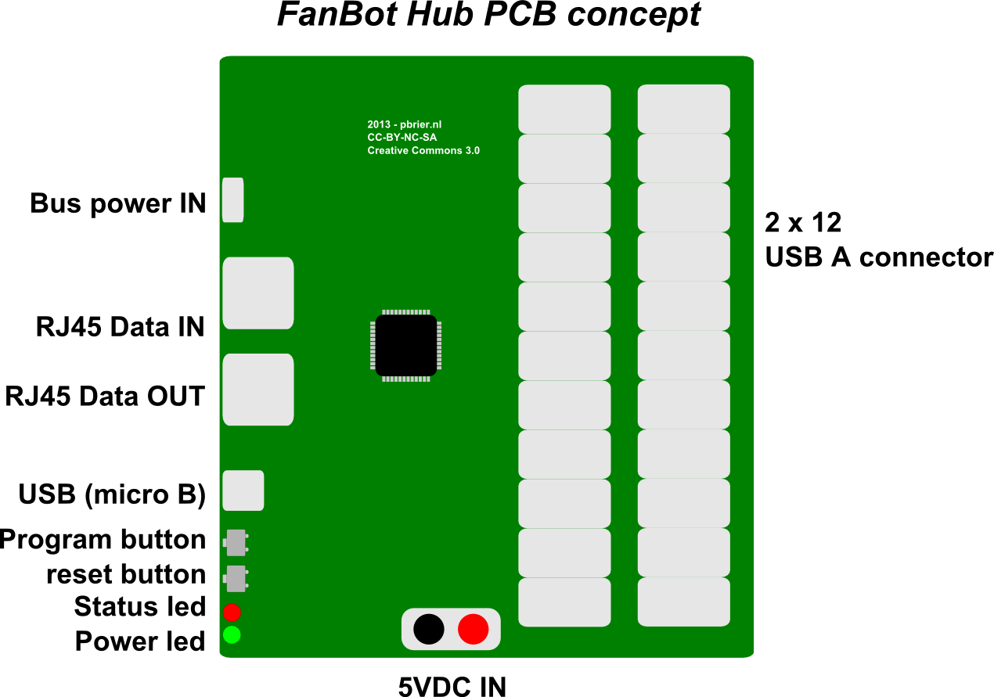
Fanbot 44xHUB

Power supply
The board is powered by a 5VDC power supply (150W). The bus is powered by a 12VDC voltage (current per node <50mA).

Communication

HUB Communication
The Hub receives commands via an isolated RS485 link.

Physical connection | RJ45, 4 wire (D+/D-, GND, 12V)
Electrical signalling | RS485 half duplex
Link protocol | Asynchronous, 115200 bps, 8 bits, no parity, 1 stop bit
Application Protocol | “DMX like” with additional functions

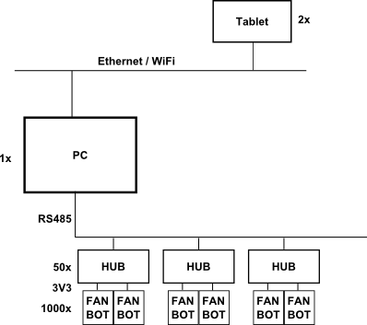

The network communication is performed via a serial link from the PC to the hubs. The PC can issue a number of commands.

PC to HUB Communication protocol
From PC to HUBS via RS485 bus

Message format
Byte | Meaning
0 .. 1 | Start of message: Allways '#' + '#'
2 .. 3 | Opcode 16 bit opcode. (LSB first)
4 .. 5 | 16 bit Length (LSB first) of subsequent data (excluding checksum)
6 .. [length + 6] | 8 bit binary data (can be zero length)
[Length + 6] .. [Length + 7] | 16 bit checksum (LSB first)

All messages that do not have a valid CRC will be ignored. A message needs to be sent as a continuous stream of data. If a message transmission is interrupted for more than halve a second, the message is ignored. Subsequent data is ignored until a “start of message” and valid opcode.

Opcodes
NR | Name | Direction | Data
1 | REQUEST_ID | PC → HUB | All nodes that are not tagged will send their ID on the bus after a random time [0 to 1 sec]
2 | TAG_ID | PC → HUB | 4 bytes (UID). The hub that is tagged (its UID corresponds to the UID data) wil not respond to any REQUEST_ID commands.
3 | PLAY_FRAME | PC → HUB | 128 bytes (1024 bits) with play status  Send a bitmapped block of data to all hubs. Each hub will decode the appropriate bits and send their state to the robots via the hub outputs
4 | LED_FRAME | PC → HUB | 128 bytes (1024 bits) with led status (ON/OFF)
5 | POS_FRAME | PC → HUB | 256 bytes (2048 bits) with servo position status (2 bits / port, 0=OFF, 1=LEFT,2=MIDDLE,3=RIGHT)
6 | REQUEST_STATUS | PC → HUB | 4 bytes (UID).  The addressed slave will respond with their unique ID and status information in the HUB_STATUS_REPORT
7 | CONFIG_FRAME | PC → HUB | 4 + 48 bytes (8 bytes UID and 24 x 16bits indexes for all outputs)
128 | ID_REPORT | HUB → PC | 4 bytes (UID of HUB)
129 | STATUS_REPORT | HUB → PC | 4 bytes (UID of HUB) + 128 bytes additional status information containing the 24 x 4 bytes UID of the connected robots. Followed by the 4 byte UID of the hub, and 4 byte software revision code of the hub
0xDEAD | RESET | PC → HUB | Cause a reset of the hubs

Opcode 1: Send data frame
The data frame on the bus will be read by all slaves. Each slave decodes the appropriate bits, as configured using the config frame and send their state to the outputs.

Opcode 2: REQUEST_HUB_STATUS
This message is similar triggers the hub with a UID that matches the supplied UID to send its UID and status information. The hub is required to respond as soon as possible and WITHIN 0.1 sec to this message. There is a special situation when the UID is equal to 'everyone'. In that case all slaves will wait a random time (0.1 to 5 seconds) and send their information. This can be done to identify all slaves on a bus, when it is unknown what their UID's are.

Opcode 3: SEND_CONFIG_FRAME
Upon reception of this frame by the slaves, they will check if the first 8 bytes match their ID and if so it will decode the rest of the data. Each 16 bit data item identifies a bit number in the data frame to decode for a given output. The first 16 bit corresponds to output “0” (the first output).

Opcode 4: HUB_ID_RESPONSE
This message is sent by the hub, in response to an IDENTIFY_HUBS or REQUEST_HUB_STATUS

Fanbot positions and addressing
The slaves are arranged in a matrix according to the following layout.

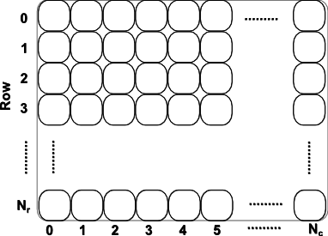

Each hub drives up to 24 cells the matrix. The matrix has 50 columns and 20 rows.
The hubs are configured to respond to the appropriate bits in the data frame, via their configuration.

Communication between HUB and robot
The communication between the hub and the robot is performed using a asynchronous serial protocol. 9600Bps, 8 bits, no parity, 1 stopbit.

Physical connection | USB cable/connector 4 wire (DP/DM, GND, 5V)
Electrical signalling | 3V3, RS232 half duplex
Link protocol | Asynchronous, 9600 bps, 8 bits, no parity, 1 stop bit
Application Protocol | Specific

Communication Protocol between HUB and robot
The HUB can send a number of opcodes to the Fanbot brain board.

Opcodes
NR | Name | Direction | Data
1 | PLAY [p] | HUB → FAN | N.A.
2 | STOP [s] | HUB → FAN | N.A.
3 | SET_LEDS [L][#] | HUB → FAN | 1 byte (8 bit LED status)
4 | SET_SERVO1 [A][#] | HUB → FAN | 1 byte (8 bit servo position)
5 | SET_SERVO2 [B][#] | HUB → FAN | 1 byte (8 bit servo position)
6 | GET_NUMBER [n] | HUB → FAN | N.A.
7 | GET_NAME[N] | HUB → FAN | N.A
 | NAME | FAN → HUB | 32 bytes
 | ID | FAN → HUB | 8 HEX digits [0..F]

Opcode 1: PLAY
Program number 1 is executed immediately. It is executed once. If a new PLAY opcode is received while a program is running, the program will be interrupted and started again at the start. At the end of the program, the final state of the LEDs will remain.

Opcode 2: STOP
The running program is suspended immediately. Movement of the servo is stopped and all leds are turned off.

Opcode 3: SET_LEDS
The forces the outputs to a certain state. If a program was running, it is immediately stopped and the provided LED state is assumed

Opcode 4: SET_SERVO1
Send a position for servo 1 to the robot. If a program was running, it is immediately stopped and the provided SERVO1 position is assumed

Opcode 4: SET_SERVO2
Ridential to SET_SERVO1, but controlling servo 2

Opcode 6: GET_NUMBER
The robot sends the 32 bit serial number as 8 hex digits

Opcode 7: GET_NAME
The robot sends the content of the name memory as 32 hex characters (null value if not entered)

Communication between PC and Fanbot
A PC can communicate directly to a Fanbot using the USB connection. Two communication modes are available: MSD (Mass storage Device) and HID (Humane Interface Device).

Physical connection | USB cable/connector 4 wire (DP/DM, GND, 5V)
Electrical signalling | USB high speed (12MHz)
Link protocol | HID (Note: MSD is used to flash firmware)
Application Protocol | Specific
Message length | Fixed 48 byte messages
PID/VID | HID: 0x1234 / 0x1234  MSD: 0x1FC9 / 0x000B

MSD mode
MSD mode is activated when the program key is pressed while the USB connector is inserted, OR when
no valid firmware is present on the chip. MSD is the default mode when the chip is not yet programmed.
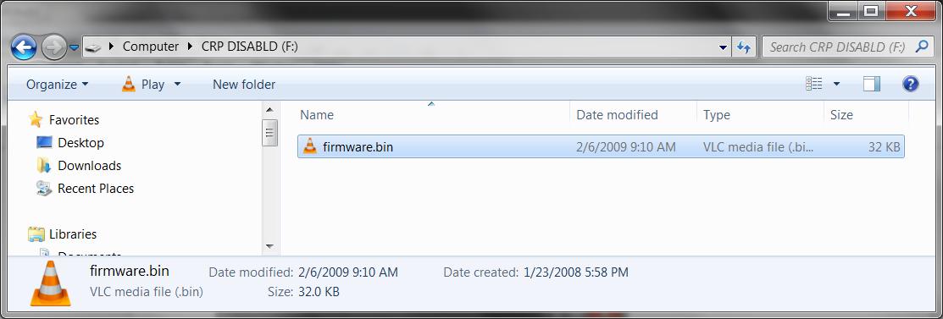
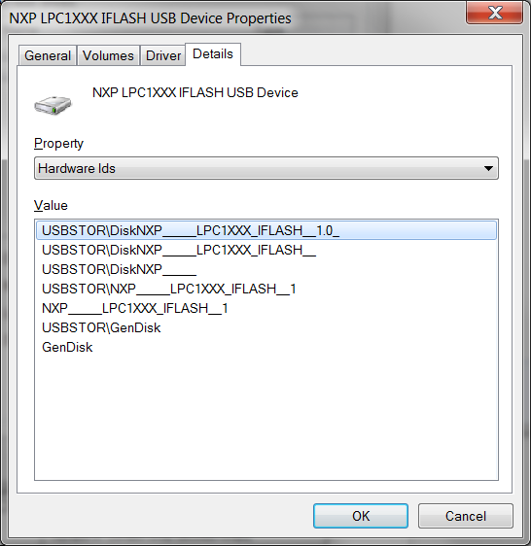
A drive with the volume name “CRP DISABLD” and a single file “FIRMWARE.BIN” is presented to the OS. This file can be deleted or overwritten. A new firmware file can be copied over the exitsing file. The name of this file is not significant. The size should be smaller than the available FLASH size. The BIN file should be a valid LPC ARM executable with a valid CRC (see NXP application note). To activate the new firmware, the board needs to be reset.

HID mode communication
The HID mode is activated when the fanbot firmware is operational. The HID protocol allows sending and receiving of fixed length messages. The messages have a maximum length of 64 bytes.

Message format (PC → FAN)
Byte | Name | Description
1 | Opcode | The opcode specifies what the fan should do. See the list with opcodes for more information
2 .. 63 | Data | Optional data for the opcode. If not used, the content is ignored. The data should be transmitted in each frame.

Opcodes (HID write)
NR | Name | Direction | Data
0 | SET OUTPUTS | PC → FAN | Byte 1: LEDs (bit mapped. Bit 0 is Left eye, bit 1 is right eye, bit 2 is left mouth, etc.)  Byte 2: Servo 1 output  Byte 3: Servo 2 output
1 | Write EEPROM data | PC → FAN | Byte 1: Memory bank (0=program or 1=name)  Byte 2..62: Data.  Memory bank 0: First Program
2 | PLAY | PC → FAN | Play current frame
3 | NAME | PC → FAN | Set the name string (byte 1..33 is ASCII name)
4 | STOP | PC → FAN | Stop playing

Message format (FAN → PC)
Byte | Name | Description
1..8 | Serial number | The serial number is read from the microcontroller
9 .. 41 | Name | The name of the robot. Read from memory bank 8.

Communication between Control application and proxy
The proxy application receives information via a TCP/IP socket and forwards the data via USB (serial) to the RS485 HUB network. It can serve multiple clients.

Physical connection | Ethernet (wired/wireless)
Protocol | TCP/IP
Network configuration | Private IP range, Private ESSID wifi router with DHCP server
IP-Range | 192.168.88.0/8
ESSID / PW | FANBOT / TRIBUNE10
IP addres | 192.168.88.100
Port | 2013

On the tcp/ip port, the following protocol is used:

Opcodes
CHAR | Name | Direction | Function
'^' | START_OF_FRAME | CLIENT → SERVER | Set cursor to (0,0), current frame is sent to the fanbots
'\n' | NEW_LINE | CLIENT → SERVER | Increment cursor y coordinate and set x to zero
'*' | SET_ON | CLIENT → SERVER | Set pixel (x,y) on, and increment x
'.' | SET_OFF | CLIENT → SERVER | Set pixel (x,y) to OFF and increment x

Software
There are various software components in the system.

Control application
The control application has a number of buttons that trigger these functions:

1) Initialize bus (reads the config file and sends the config data to all hubs)
2) Identify slaves (shows all identified hub UID's in a list)
3) Go Live (this enables the bitmap buttons and live area and starts sending data)

In live mode, there are a number of “bitmap” buttons that trigger the transmission of a single data frame or a number of dataframes (a sequence of multiple bitmaps). Each bitmap is 42 pixels wide and 24 pixels high.

In the “live area” you can see the actual data that is sent to the slaves and “paint” over the 42x24 pixel canvas with the mouse (various brushes: ON/OFF and TIME). Where the TIME brush turns on the pixels for a fixed amount of time (eg. 0.5 sec).  In live mode, data frames are sent continuously to the hubs at several frames/sec. The hubs are polled one by one to update the status on the screen.  The control application is visible on the PC, and can be controlled via a tablet using a Java applet in a browser (or native Android app?) | Tablet user interface: Allow to select preset bitmaps and animations, and manually paint on the live canvas

Control application use case
The soccer matches are hosted by one or two hosts who will comment on the game and entertain the audience during the break. The walk around with a wireless microphone and during the break they join the audience on the stands to answer their questions. One of these hosts will also control the fanbots with a tablet in the following situations:

Situation | Fanbot reaction | Program | HMI
When a team scores | The fanbots on one site cheer | Made by the kids (2-4 secs)
Begin/end of the game | All the fanbots cheer for 5 sec | Made by the kids (2-4 secs)
During the game | Some random robots will cheer | Made by the kids (2-4 secs) | Preset button
During the game | A wave is done | All on | Preset button (left to right and right to left)
During the game | (Nice:) play short gif movies | All on | Select from a list
During the breaks | The audience/host can draw a pattern of waving fanbots (stay on about 1 sec and then die out) | All on | Draw on tablet
During the breaks | (Nice:) play short gif movies | All on | Select from a list (make a queue)

Fanbot program
The fanbot should be able to wave (servo movement) and flash (7 LEDs).
The movement must be fixed between two maximum values (180º is too much, approx 60º-90º)
For the wave and gif animation the fanbots must have a second programm with 4 LEDs on and all LEDs on (movements?)

Workshop programming tool
In the workshop, the participants can program the tool, using a simple user interface. It allows the user to make “Moves” and switch the LEDs ON and OFF. Programming is done in the form of a “comic strip”.

Naam: Pietje
3
1
2
4
5
6

SAVE

STOP

START

- LEDS can be programmed individually
- Sequence of 10-20 steps for LEDs
- Servo movement are set with a slider for each step in the program.
- When a LED is toggled on the screen of the slider position is changed, the data is sent directly to the connected hardware to update the state in real-time.
- When the “RUN” button is pressed, the sequence is programmed in the EEPROM of the robot, and the sequence is executed. The state is updated in real-time on the screen of the computer.

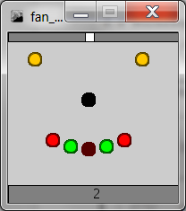Illustration 1: Example of fanbot user interface element. The LEDs can be toggled on/off. The top slider can move from left to right to change the arm position. Pressing the centre (nose) will store the sequence and start the playback. The step number can be selected using the bottom slider.

Additional functions for the workshop tool

The program should copy a specified file when a drive is detected with a volume name “CRP DISABLD” that contains a file FIRMWARE.BIN. The FIRMWARE.BIN file should be overwritten with the new file content. Once copied, the file content should be verified

A pictogram should indicate the state of the program.
State | condition | Pictogram
1 CONNECT ROBOT | No robot is detected (no MSD or HID communication) | Robot with cross
2 COPY FIRMWARE.BIN | The FIRMWARE.BIN file is being copied and verified | Robot busy with file
3 FIRMWARE OK | The written firmware file matches the required firmware. | Disconnect robot
4 ROBOT READY | HID communication active | Robot with serial number and name
5 ROBOT ERROR | Unspecified error | Robot with question mark

Fanbot HID interface program

The Fanbot HID interface program is a standalone ececuteable that can be started from the human interface. It will handle all communication with the fanbot. It is controlled via the Standard input and reports state information via the standard output using simple ASCII commands and event.

When the program is started it will wait for a FanBot to be connected to the computer.

State # | State | INPUT | OUTPUT
The program is started
1 | Wait for robot to connect | - | -
2 | Robot connected |  | CONNECT [serial#]
 |  |  | PROGRAM [l1] [s1] .. [n1] [sn]
 |  | SET [leds] [servo]
 |  | PROGRAM [l1] [s1] .. [ln] [sn]
 |  | NAME [ASCII NAME]
 |  | PLAY
3 | Disconnected |  | DISCONNECT
The program will terminate with exit code 0

The controlling application will monitor the existence of a “firmware.bin” file on a pre-configured path. If this file appears, it will be overwritten with the pre-defined firmware file.

The HID communication application will be continuously restarted from the controlling application. After starting, it will wait for the “CONNECT” message.

The controlling application should save the name in the robot using the NAME command each time the name is changed on the screen.

The user is now able to create program steps and download the program. Each time the program is downloaded it is also played.

Stand

Stand matrix (44x24 Fanbots, 24 per Hub), 10,5m x2,9m x 2,4m (lxwxd)

Schematics & Bills of materials

Fanbot Electrical schematics (obsolete by last production designs)
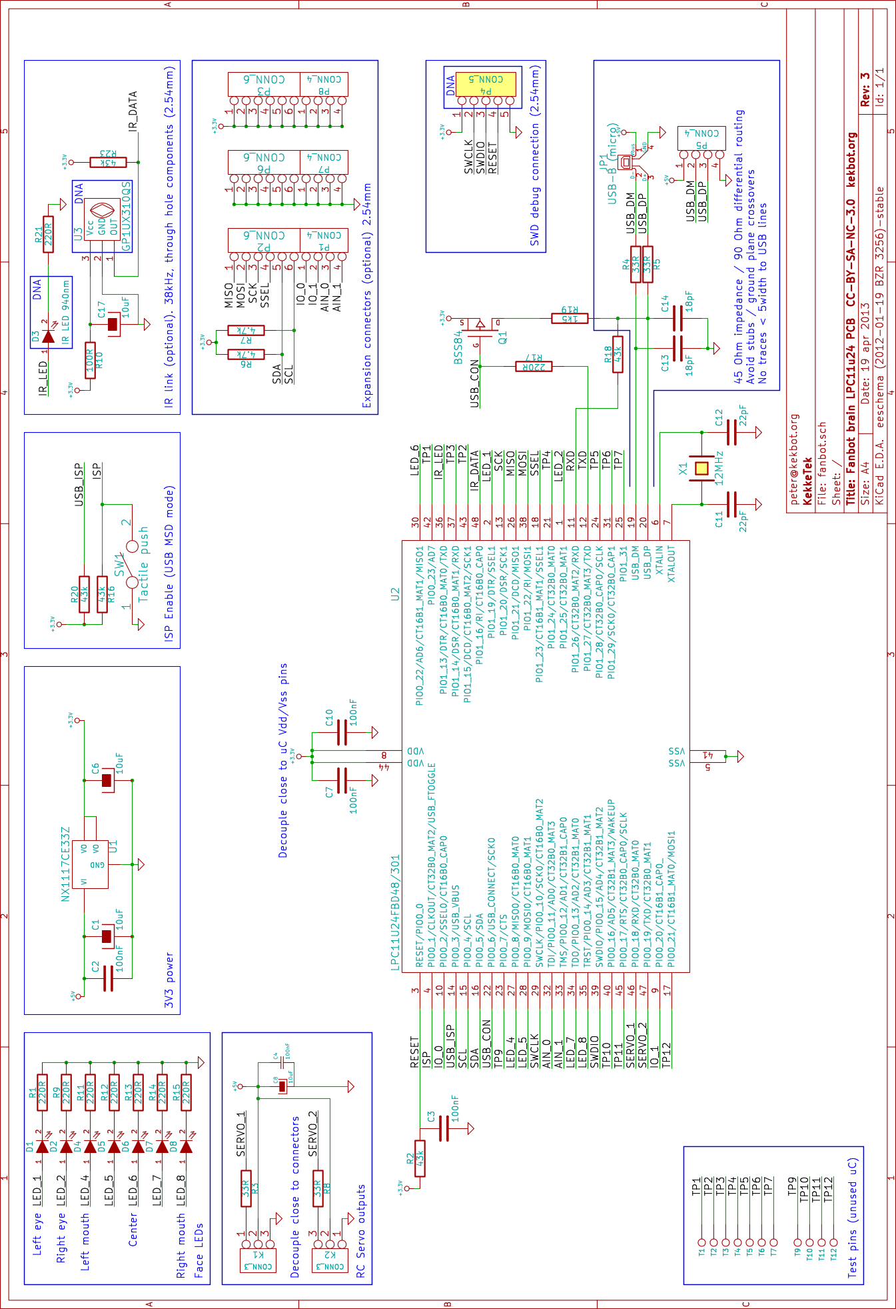

Fanbot Bill of materials (obsolete by last production designs)
Fanbot Components | spec | Nr / robot | Tot. nr | ref | Remarks
Capacitor | 100nF | 6 | 9000 | C2, C3, C4, C7, C10, C16
Resistor | 100R | 1 | 1500 | R10 | Optional (IR)
Resistor | 10K | 1 | 1500 | R23 | Optional (IR)
Capacitor | 10uF | 4 | 6000 | C1, C6, C8, C15
Capacitor | 10uF | 1 | 7500 | C17 | Optional (IR)
Crystal | 12MHz | 1 | 1500 | X1
Capacitor | 18pF | 2 | 3000 | C13, C14
Resistor | 1k5 | 1 | 1500 | R19
Resistor | 220R | 7 | 10500 | R1, R9, R11, R12, R13, R14, R15,
Resistor | 220R | 1 | 1500 | R21 | Optional (IR)
Capacitor | 22pF | 2 | 3000 | C11, C12
Resistor | 2k | 2 | 3000 | R6, R7
Resistor | 33R | 2 | 3000 | R4, R5
Resistor | 43k | 3 | 4500 | R2, R16, R?
Resistor | 5K | 2 | 3000 | R17, R18
Resistor | 68R | 2 | 3000 | R3, R8
Connector | CONN_10 | 3 | 4500 | P1, P2, P3
Connector | CONN_3 | 2 | 3000 | K1, K2
LED | IR_LED | 1 | 1500 | D3 | Optional (IR)
Microcontroller | LPC11U24FBD48/301 | 1 | 1500 | U2 | NXP microcontroller, to be confirmed.
 | NX1117C | 1 | 1500 | U1
LED | RED | 2 | 3000 | D1, D2, | Different colours are nice, there are 2 LEDs for the eyes and 5 for the mouth
LED | GREEN | 3 | 4500 | D4, D5, D7, D8
LED | YELLOW | 2 | 3000 | D6
IR reciever | SFH-5110 | 1 | 1500 | U3 | Optional (IR)
 | SPST | 1 | 1500 | SW1
 | SWD | 1 | 1500 | P4
Connector | USB-B | 1 | 1500 | JP1
others
PCB Fanbot | 2 layer, 5x5 cm | 1 | 1500 | Eurocircuits
SERVO |  | 1 | 1500 | Ordered
USB cable | Micro USB, 1m | 1 | 1500 | Ordered in 9 colours
Carboard body |  | 1 | 1500 | Laser cut material
Split pins |  | 4 | 6000 | Officecenter?

Fanbot PCB layout

Mechanical and layout considerations
Important mechanical and layout considerations:
- All through hole connectors on 2.45 mm pitch, at the edge of the board as much as possible
- Signal pins of option connectors (P1/P2) can be swapped if required for proper layout
- Test pin pads 1.5 mm, any location allowed
- LED locations and mounting hole exact position defined in drawing

Component | Type | Location
SW1 | Tactile switch | Center of board (front side)
JP1 | USB micro B | Bottom edge, left aligned, cable facing down (front side of PCB)
K1 | 2.54mm pins, right angle | Bottom edge, right aligned, cable facing down (front or back side of PCB)
K2 | 2.54mm pins, right angle | Right edge, bottom aligned, cable facing right (front or back side of PCB)
D3 / U3 | IR LED, IR receiver, 2.54mm pitch (not mounted) | Top edge, right aligned
P4 | 2.54 mm header (not mounted) | Right edge
D1 .. D8 | SMD Leds | Exact location defined in drawing “fanbot-brain.dxf”
H1 | Hole 3.5 mm | Exact location defined in drawing “fanbot-brain.dxf”

Silkscreen Front
The front silkscreen will include the following identifications:

Identification | Text
PCB name | Fanbot brain
Licence | CC-BY-SA-NC-3.0
Website | KekBot.org
SW1 | Program
JP1 | USB
K1 | SERVO1, +5V, SIG1, GND
K2 | SERVO2, +5V, SIG2, GND
D3/U3 | IR
P4 | SWD, -, R, D, C, +
P1,P2,P3,P6,P7,P8 | 1, 2, 3, 4, SDA, SCL, 7, 8, 9, 10, 3V3, GND, SIG

Silkscreen Back
The back silkscreen will include the logos of the various sponsors

Logo | Bitmap
AME
Arrow
Eurocircuits
KekkeTek | 
RoboCup | 

Fanbot HUB Electrical schematics
t.b.d.

Fanbot HUB Bill of materials
!!! TO BE UPDATED WITH FINAL BOM !!!
HUB Components | spec | Nr / robot | Tot. nr | ref | Remarks
LITTELFUSE- 1812L125/16DR | 1.25A | 24 | 960 | F1, F2, F3, F4, F5, F6, F7, F8, F9, F10, F11, F12, F13, F14, F15, F16, F17, F18, F19, F20, F21, F22, F23, F24 | 1836775 | 0.34
Capacitor | 10000uF | 4 | 160 | C2, C16, C19, C20
Capacitor | 100nF | 10 | 400 | C1, C3, C4, C6, C7, C11, C12, C15, C17, C18
Resistor | 100R | 24 | 960 | R7, R8, R11, R12, R20, R21, R22, R23, R24, R25, R26, R27, R28, R29, R30, R31, R32, R33, R34, R35, R36, R37, R38, R39
Resistor | 10k | 3 | 120 | R4, R5, R19
Capacitor | 10uF | 2 | 80 | C9, C10
Resistor | 120R | 2 | 80 | R2, R42
Resistor | 12MHz | 1 | 40 | X1
Capacitor | 18pF | 4 | 160 | C13, C14, C21, C22
Resistor | 1k | 3 | 120 | R15, R44, R45
Resistor | 1k5 | 1 | 40 | R16
Resistor | 22k | 1 | 40 | R13
Resistor | 330R | 5 | 200 | R1, R3, R6, R43, R46
Resistor | 33R | 2 | 80 | R17, R18
Capacitor | 4u7 | 2 | 80 | C5, C8
 | 5.6V | 1 | 1206 | VR1 | 1189317 | 0.6  AVX - VC120605D150DP
Resistor | 560R | 4 | 160 | R9, R10, R40, R41
 | ADM2484 | 1 | 16SOIC | U2 | 2067811 | ANALOG DEVICES
MOSFET, P, SOT-23, 0.1 | BSS84 | 1 | SOT-23 | Q1 | 1510765 | 0.1
DIODE (FAIRCHILD SEMICONDUCTOR - RURG5060) | DIODE | 2 | 80 | D2, D8 | 1651155 | 2  FAIRCHILD SEMICONDUCTOR - RURG5060
 | DIPS_04 | 1 | 40 | SW3
LED | GREEN | 2 | 80 | D1, D6
JUMPER | JUMPER | 1 | 40 | JP1
 | LPC11U35FBD64/401 | 1 | LQFP64 | U4 | 2115655 | 3.00
 | NX1117CE33Z | 1 | SOT-223 | U1 | 2057285 | 0.25
 | NX1117CE50Z | 1 | SOT-223 | U3 | 2057286 | 0.27  NXP - NX1117CE50Z
LED | ORANGE | 1 | 40 | D3
 | POWER | 2 | 80 | P1, P2
 | R | 1 |  | R14
LED | RED | 2 |  | D4, D7
 | RJ45IN | 1 |  | J13
 | RJ45OUT | 1 |  | J14
DIODE, SWITCH, 100V, 0.7A.DO-219AB | S07B-GS08(>1A) | 1 | DO-219AB | D5 | 1864884 | 0.06  VISHAY SEMICONDUCTOR - S07B-GS08 -
 | SPST | 2 |  | SW1, SW2
 | USB | 1 |  | J15
Connector | USBA-D | 12 |  | J1, J2, J3, J4, J5, J6, J7, J8, J9, J10, J11, J12 | 0.28 | USB-AW-2
others
PCB HUB | 2 layer, 10x15 cm | 1 | 40 | Eurocircuits, to be confirmed

Tinkering materials
During the workshop for pimping the fanbots:
- Tinkering materials: tape, glue, felt-tips, coloured paper, wire,..
- Scrap: wiring harness, small plastic caps, connectors, nice looking parts, …

